**Project Initialization and Planning Phase**

| Date | 15 August 2024 |
| --- | --- |
| Team ID | LTVIP2024TMID24785 |
| Project Name | Customer Segmentation Using Machine Learning |
| Maximum Marks | 3 Marks |

**Define Problem Statements (Customer Problem Statement Template):**

I am **concerned about my risk** of developing chronic kidney disease (CKD), especially since it often progresses silently until it's too late. **I'm trying to take control of my health** by monitoring my symptoms and risk factors, but **I don't know how to identify the early warning signs**. There's a lot of information out there, but it’s hard to tell what’s reliable or tailored to my specific needs.

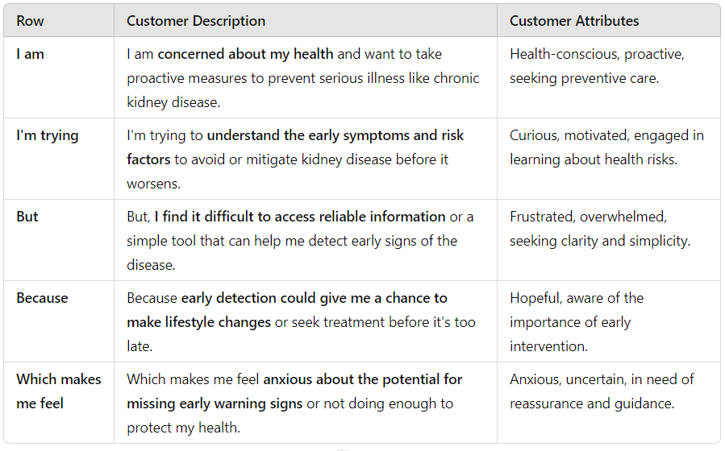

**Example:**

|  |  |  |  |  |  |
| --- | --- | --- | --- | --- | --- |
| **Problem**  **Statements (PS)** | **I am**  **(Customer)** | **I’m trying to** | **But** | **Because** | **Which makes me feel** |
| PS-1 | I’m Concerned  About my Health | Understand the early symptoms | Difficult to access Information | Early detection  Could save a life | Anxious,  Nervous |
| PS-2 | Proactive seeking  Preventive care | Detection of Disease | I don’t know  About it | Hopeful on Early Detection | Worried, Seeking peace of mind. |